**Instructions to run NCSystem on MAC OS X for the first time**

1. Download the .app and put it into the *Applications* folder.
2. Try to run NCSystem.app, the following window may appear, it’s ok.

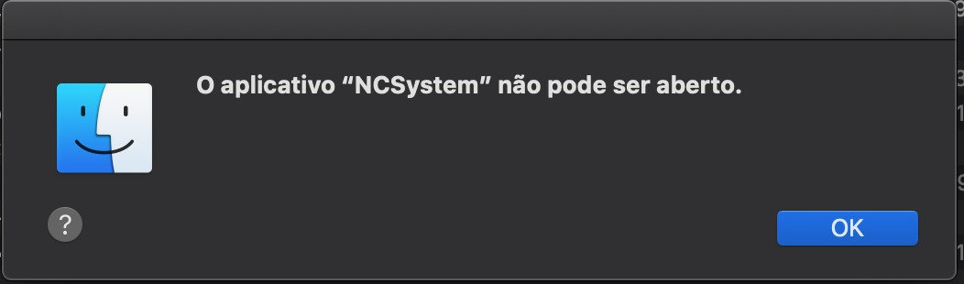

1. Run this command in the terminal:
   1. chmod +x "/Applications/NCSystem.app/Contents/MacOS/NCSystem"
2. Try to run NCSystem.app again, the following window may appear, it’s also ok.

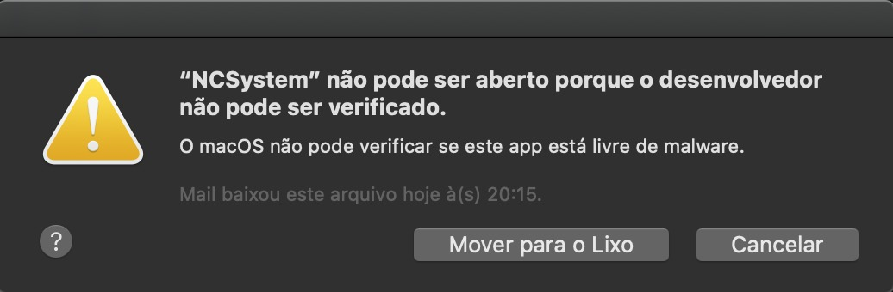

1. Allow the app execution, follow the below screenshot.

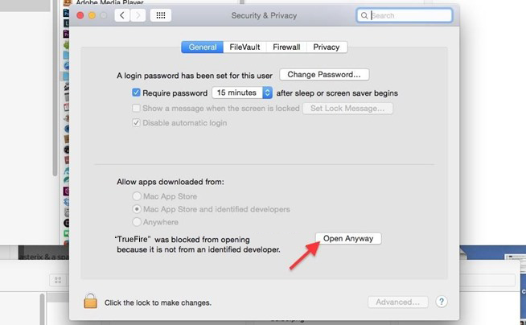

1. Now, NCSystem.app will open properly.

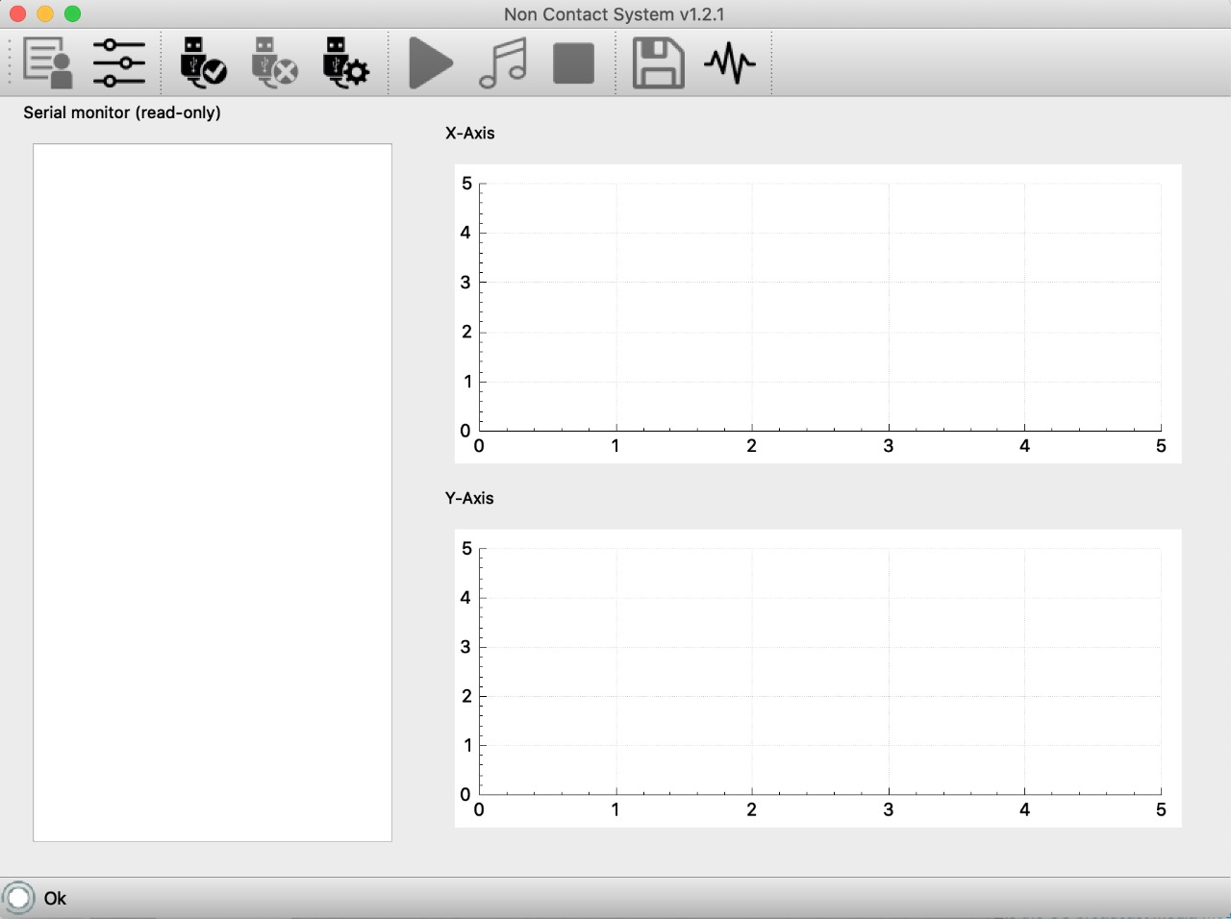

Dev contact:

Fábio Henrique (fabio.oliveira@ifb.edu.br)